”Lead, Develop and Promote Positive Lifelong Hockey Experiences”

BC Hockey Championship

U18 Tier 2
March 15th – March 18th, 2026



Hosted By
Kelowna Minor Hockey Association

Table Of Contents

Page 3…………………………………………………………….Contact Information
Page 4…………………………………………………………….Banquet Information
Page 4…………………………………………………………….Coaches and Managers Meetings
Page 5…………………………………………………………….Opening/Closing Ceremonies/raffle
Page 6…………………………………………………………….Schedule
Page 7…………………………………………………………….Location Details
Page 8…………………………………………………………….City of Kelowna
Page 9…………………………………………………………….Sport Stores Locations
Page 10……………………………………………………………Medical Facilities
Page 11…………………………………………………………...Accommodations
Page 12……………………………………………………………Things To Do
Page 13……………………………………………………………Restaurants
Page 14……………………………………………………………Transportation Information
Page 15……………………………………………………………Apparel
Page 16……………………………………………………………Team Requirements

Contact Information

Kelowna Minor Hockey Association (KMHA)
425 Doyle Ave, Kelowna, BC, V1YOM5
(Memorial Arena)
Daryle Assman, Executive Director
execdir@kelmha.com
Phone: (250) 861-5677
Fax: (250) 861-5358

Host Planning Committee

Name | Position (Lead) | Email
Kendra Stewart | Chair | tournaments@kelmha.com
Mark Watson | Committee member
 |  | N/A
 |  | N/A
 |  | N/A

BC Hockey/Officials Representatives

Name | Position | Email
Mike Rispin | BC Hockey Rep/Supervisor | Mdrispin@gmail.com
Larry Lenarduzzi | Officials Representative/Supervisor | ric@kelmha.com

Schedule and Scores
https://championships.bchockey.net/schedules/186430

U18 Tier 2 Provincials Facebook Page

https://www.facebook.com/groups/919011026764911/?ref=share&mibextid=NSMWBT

Banquet Information

A banquet will be held for all players, coaches, and team managers. The BC Hockey Representative and Officiating Supervisor will also be in attendance. Team attendance to this banquet is mandatory. A guest speaker will be addressing the group and a full meal will be provided.

Date: Saturday, March 14

Time: 5:30 PM -8:00 PM. Please make sure that players are dropped off at the banquet no later than 5:15 PM and no sooner than 5:00 PM. They can be picked up starting at 8:00 PM.

Location: Four Points by Sheraton Kelowna Airport
5505 Airport Way, Kelowna, BC
Four Points by Sheraton

Attire: Country Western. There will be an award for best dressed!

Menu: Food will be buffet style pasta. Caesar salad, Penne Alfredo, Grilled Chicken, fusilli bolognese, garlic toast, assorted desserts, selection of juice and pop.

Coaches/Managers Meeting

A Coaches and Managers meeting will be held on March 14th. It will be held immediately after the banquet and at the same location. It is mandatory for all coaches and managers to attend.

The meeting will include pertinent information relating to the tournament including rules and regulations and introductions to key tournament contacts. A BC Hockey representative will be in attendance to answer questions teams have.

Date: Saturday, March 14th

Time: 8:00 – 9:00 PM

Location: Four Points by Sheraton Kelowna Airport
5505 Airport way, Kelowna, BC

Opening/Closing Ceremonies/Raffle

The opening and closing ceremonies will be held at:

MNP place Arena 1
4105 Gordon Drive, Kelowna
https://goo.gl/maps/fXf9Q6XKrzbVDbbQ7

The opening ceremony for the tournament will be held in the evening on the first day of tournament play. All teams are required to attend. Teams will be welcomed to the tournament and the anthem will be played. Opening remarks will be made by a local official.

Date: Sunday, March 15

Time: 430 PM

The closing ceremony for the tournament will take place immediately after the final game of the tournament. The Championship Banner, medals and Fair Play Trophy will be presented. We encourage all teams to attend but it is not mandatory.

Date: Wednesday, March18th

Hats and medals awarded after last game

There will be a raffle table and a 50/50. The 50/50 will open prior to the event. For
the raffle table we are asking each team to donate a basket. We are aware that some teams will
qualify for Provincials on short notice and have limited time to put together a basket. Any
donation to the raffle table will be appreciated.

Schedule

Tournament Location

All games for the tournament will be held at the MNP Place: https://mnpplace.com

Address: 4105 Gordon Drive, Kelowna
https://goo.gl/maps/fXf9Q6XKrzbVDbbQ7

Phone: (250) 764-6288

Arena: Games will be played on Rink 1 and Rink 2.
MNP Place does not have skate sharpening services on premises.
Concession on Premises.

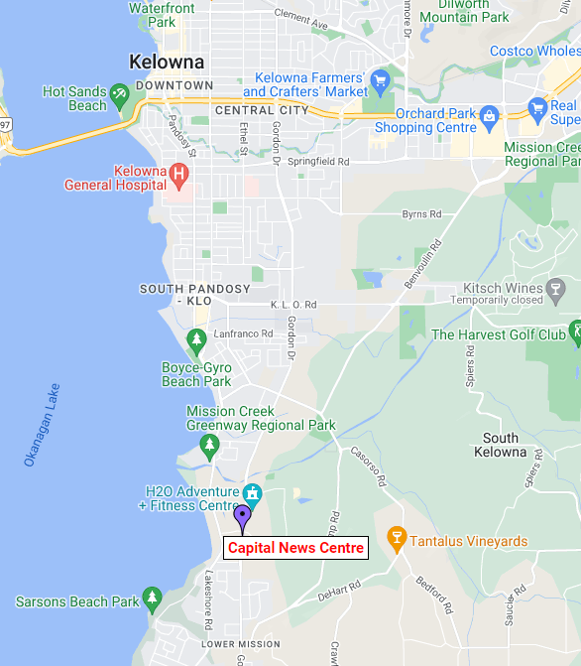


City of Kelowna

Kelowna sits on the traditional, ancestral, and unceded land of the syilx/Okanagan people.

Urban and rural; nature and culture; playtime and downtime: Kelowna isn’t just one destination. It’s a whole bunch of them, located in one uniquely beautiful place.

Cradled within a glorious range of mountains, is a sanctuary filled with pristine lakes, pine forests, abundant gardens, orchards and vineyards, sandy beaches and superb amenities. Stretching from north to south for approximately 135 km (84 miles) is beautiful Okanagan Lake. The lake sustains several diverse communities along this corridor known as the Okanagan Valley. It is a semi-arid climate, boasting long warm summers and short mild winters.

The city of Kelowna has a population of 165 000 and is the transportation, business and service hub of the valley. In cooler months, our snow-capped mountains and pine filled forests are a haven for skiers, boarders, snowmobilers and outdoor adventurists of all types.

Orchards and vineyards thrive within a 10-minute drive from the downtown core and provide seasonal delights year-round. Kelowna’s growing Cultural District covers a six-block downtown area and features a concentration of galleries, museums, theatres, a casino, artists’ studios, fine dining, unique shops and a vibrant cultural life all year long.

tourismkelowna.com

Sports Stores and Skate Sharpening

Chevy's Source for Sport  # 126-1878 Cooper Rd  Hours: M-F 9-6,  Sa 9-5:30, Su 10-4  Phone: 250.712.0777  Chevy's Source for Sports  Sport Chek Kelowna  (In Orchard Park Mall)  2271 Harvey Ave  Hours: Sa-T 10-6,  We 10-7 Th-F 10-8  Phone: 250.860.7669  Kelowna Sport Chek | Play it Again Sports  1778 Baron Road  Hours: M-F 9:30-7  Sa 9:30-6, Su 10-5  Phone: 778-484-0048  Play It Again Sports Kelowna

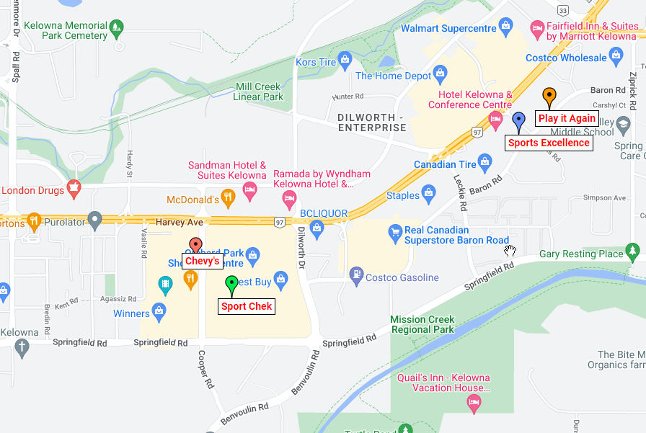
Medical Facilities

Kelowna General Hospital
2268 Pandosy St V1Y 1T2
Emergency department: Open 24 hours
https://goo.gl/maps/J5VDYRHHNPpcmTyt5

Kelowna Urgent Primary Care Centre
1141 Harvey Ave
250-469-6985
Hours: 9:30 am to 8:30 pm
https://goo.gl/maps/ivZrhJycfgjApJuV7

Walk in Clinic Locations & Wait times Kelowna
https://medimap.ca/Location/Kelowna%2C%20British%20Columbia%2C%20Canada

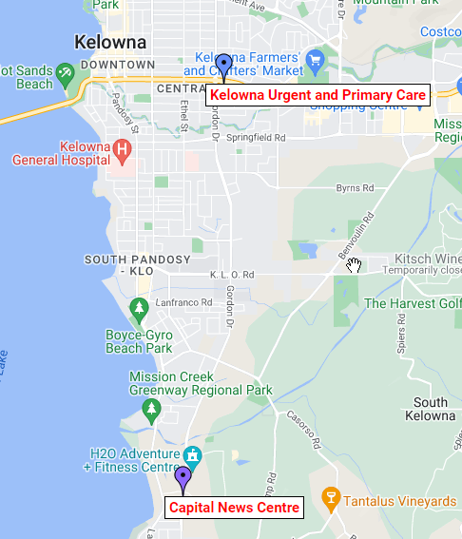
Accommodations

Hampton Inn & Suites by Hilton Kelowna Airport 1665 Innovation Drive V1Y V1V 2Y9 Phone: 250-765-9042. Contact: Sarah (Four Points available as well)
Kelowna Hotels - Hampton Inn and Suites Kelowna Airport (hilton.com)

Holiday Inn Express & Suites Kelowna - East 1620 Powick Road V1X 7G5 Phone: 778.484.9136,
Holiday Inn Express & Suites Kelowna - East - Kelowna, Canada (ihg.com)

Fairfield Inn and Suites Kelowna 1655 Powick Road V1X 4L1 Phone: 250.763.2800.
Contact: Leanne
Pet-Friendly Hotel in Kelowna, Canada | Fairfield Inn & Suites Kelowna (marriott.com)

Comfort Suites 2656 Hwy 97 N V1X4J4 Phone: 250.860.9711. Contact: Sean
Comfort Suites

Best Western Plus Kelowna Hotel & Suites 2402 Hwy 97 N V1X4J1 Phone: 250.860.1212
Best Western Plus Kelowna

*Room Rates are available starting at $159 depending on the room/hotel. Suites are available at some locations starting at $189
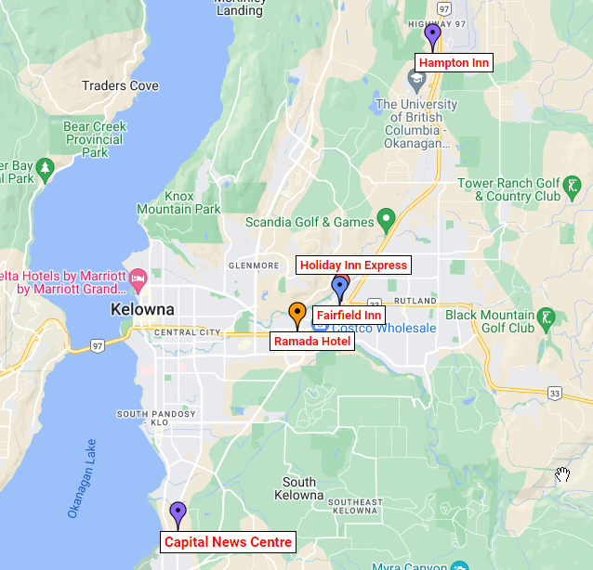
Things to Do

Movie Theatres

Landmark Grand 10 948 McCurdy Road
https://www.cinemaclock.com/theatres/landmark-grand-10

Cineplex Orchard Plaza 160-1876 Cooper Road
https://www.cinemaclock.com/theatres/cineplex-orchard-plaza

Recreation

Kelowna Rockets vs. Victoria
(Wednesday March 19, 2025 at 7:05 p.m.)
Tickets: https://kelownarockets.com

Scandia Golf & Games 2898 Hwy 97 North
https://www.scandiagolfandgames.com

Exit Kelowna Escape Games 2453 Highway 97 North
https://e-exit.ca/kelowna/

H20 Adventure and Fitness Centre 4075 Gordon Drive
https://www.h2okelowna.ca

Planet Lazer 3-1960 Springfield Road
https://planetlazerkelowna.com

Orchard Park Mall 2271 Harvey Avenue
https://www.orchardparkshopping.com

McCurdy Bowling Centre & Freddy’s Brew Pub 124-948 McCurdy Road
https://www.mccurdybowl.com

BNA Bowl at BNA Brewing 1250 Ellis Street
https://www.bnabrewing.com

Recreation for the Moms:
https://www.tourismkelowna.com/things-to-do/wineries/trails/lake-countrys-scenic-sip/

Recreation for the Dads:
https://www.tourismkelowna.com/blog/post/kelownas-walkable-trail/
Restaurants

Canadian Brewhouse #130 3030 Pandosy Street V1Y 0C4 Phone: 250.980.4521
https://thecanadianbrewhouse.com/locations/british-columbia-locations/kelowna-location/

BNA Brewing Co. 1254 Ellis St. V1Y 1Z4 Phone: 236.420.0025
https://www.bnabrewing.com/

Central Kitchen + Bar 1155 Ellis St. V1Y 1Z5 Phone: 250.862.8820
https://centralkelowna.com/

Bin 4 Burger Lounge 1616 Powick Rd. V1X 7G5 Phone: 236.420.3448
https://www.bin4burgerlounge.com/our-locations/#main

Boston Pizza - #650-2339 Hwy 97 V1X 4H9 Phone: 250.861.6677
Boston Pizza Dilworth Centre

Boomers Bar & Grill 4105 Gordon Drive V1W 4Z1 Phone: 250.764.1688 (Located at CNC)
http://www.boomerskelowna.com/

Cactus Club #200- 1575 Banks Rd. V1X 7Y1 Phone: 250.763.6752
https://www.cactusclubcafe.com/reservations/kelowna/

Yamas Taverna 1630 Ellis St. V1Y 8L1 Phone: 250.763.5823
http://www.yamastaverna.ca/menu.html

King Taps 1352 Water ST. 778.738.3989
https://kingtaps.com/locations/lakeside/

Zabb Thai 3009 Pandosy Street 778.484.3988
Zabb Thai Restaurant

Transportation Information

For the Latest Road Conditions
DriveBC

Taxi Services

Current Taxi (All Tesla Fleet) 250.864.8294
Best Taxi Service in Kelowna | Current Taxi

Kelowna Cabs 250.762.2222
Kelowna Cabs

Chekmate Cabs 250.861.1111
Taxi Services Kelowna | Home | Checkmate Cabs Ltd.

Uber is now available in Kelowna

Public Transit

BC Transit
BC Transit - Welcome to Kelowna

Apparel

For the ordering of the 25/26 BC Hockey Championships U18 Tier 2 apparel, please see below the Website:

https://bchockeyu18tier2championship.itemorder.com/shop/home/

Official Tournament Photographer - U18T2 Provincials

We are pleased to announce a partnership with TJ Kendall (Northern Element Photography), as the official photographer for our Tournament(s).
Under this collaboration, Northern Element Photography will capture hundreds of images of every team in multiple games throughout the tournament, no purchase necessary!
Instant access to these photos for viewing and purchase will be provided following each game.
More Information: HERE

Tournament Pre-Purchase Photography Package:
C$600 C$500
Guarantees your team:
400+ Photos
Every Game Captured
Every Player Captured
Scheduling Priority
Best Value
Save over $100
10% Off Customized Hockey Cards
On-Ice Team Photo
Instant Access

 | Entire Gallery | 1 Photo | 5 Photo Pack | Entire Gallery Split Cost with team of 18
Pre-Purchase | $500 | N/A | N/A | $27.78
Tournament Price | $550 | $25 | $75 | $30.55
Post-Tournament | $600 | $30 | $85 | $33.33

Split the cost with your team to receive dozens of photos per player for less than a single photo!
Remember: No Pre-Purchase necessary to receive photos of your team, Pre-Purchase provides extra perks, guarantees, and huge discounts.

Pre-Purchase: HERE

Hockey Portfolio Gallery
The best way to decide is to view the quality work for yourself:
Hockey Portfolio: HERE

About TJ Kendall and Northern Element Photography
A true professional, no other photographer has more experience capturing minor hockey at every age and skill level than Northern Element.
Everything from the first strides and goal cellies of U7 & U9’s, to future NHL Stars in elite tournaments such as the Bauer Invitational, KIBIHT and Coast2Coast International. Northern Element has experience capturing it all.


Team Requirements

Once your team is confirmed to be an entry in the tournament, please send the following information to the committee chair.

- An official team photo in high resolution .jpeg or .png format. We will be using this on our website, Facebook page, etc.
- Association Logo: Please send an EPS or Illustrator image of your association’s logo and your jersey colours.
- HCR roster
- Contact information (names, email, phone numbers and addresses for the following.
  - Coaches
  - Team Manager
- Raffle basket donation
- Home jerseys will be white/light and away will be black/dark

Thank you!
KMHA

