

Welcome to the U13 Tier 4 BC Hockey Championships
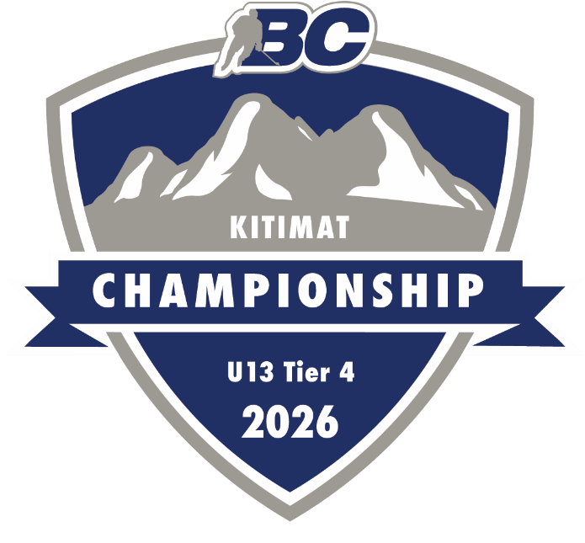

Proudly hosted by:

Kitimat Minor Hockey Association (KMHA)


March 14th – 18th 2026

Table of Contents
Contact Information 2
District of Kitimat 4
Haisla Nation 5
Tamitik Arena 6
Accommodations 7
Restaurants (Kitimat) 8
Travel To Kitimat 9
Things to do. 13
Skate Sharpening 14
Emergency Services 15
Tournament Information 16
Appendix A 19

Contact Information

Tamitik Jubilee Sports Complex
396 City Centre, Kitimat, BC
V8C 2G3
1-250-632-8955

Host U13 Tier 4 Championship
Co-Chairs – Nichol Cameron & Julie Wakita
Kitimatu13host@outlook.com
(250)639-3727 / (250)632-1104

BC Hockey – North West District
Lee Holland
nwdexecutivedirector@gmail.com

Kitimat Minor Hockey Association
Box 84, Kitimat BC
V8C 2G7
Kitimatminorhockey@gmail.com
Website- KITIMAT MINOR HOCKEY ASSOCIATION

BC Hockey Representative
Randy Henderson
Rjhend2016@gmail.com



District of Kitimat
Kitimat is located on the traditional territory of the Haisla Nation. Established in the 1950s to support industrial development, the community has grown into a diverse town shaped by people from around the world.
Nestled in northwest British Columbia at the head of the Douglas Channel, Kitimat sits along the Pacific coast and the banks of the Kitimat River. Surrounded by mountains, forests, and ocean, the community proudly balances natural beauty with industrial innovation.
Often described as “A Marvel of Nature and Industry,” Kitimat offers a unique blend of opportunity, culture, and stunning landscapes.
Population: 8,647 (2022)
More information:
https://www.kitimat.ca
https://kitimatbound.ca
https://www.youtube.com/watch?v=UeSU6KQeKTU
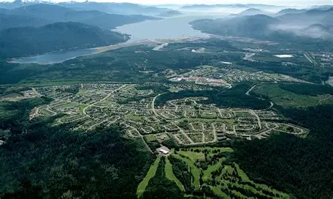



Haisla Nation
Kitamaat Village, located near Kitimat, is the home community of the Haisla Nation, whose people have lived in this region since time immemorial.
A Living Culture
The name Haisla means “dwellers downriver,” reflecting a deep connection to the land and waters of their traditional territory. Today, many Haisla citizens live in Kitamaat Village at the head of the Douglas Channel, while others reside throughout northwest British Columbia, the Lower Mainland, and beyond.
The Haisla Nation is made up of two historic bands—the Kitamaat and the Kitlope—whose territories span dramatic fjords, coastal inlets, rivers, and rainforests. Neighboring Nations include the Heiltsuk and Wuikinuxv, part of the Coast Tsimshian peoples.
Land and Water Experiences
For generations, the Haisla people have lived in balance with the land and sea. The waters of the Douglas Channel and surrounding territory have provided food, transportation, and cultural connection for hundreds of years. Stewardship of these lands and waters remains central to Haisla values today.
Visitors to the region are welcomed to experience the beauty of Haisla territory—towering mountains, rich marine life, and a vibrant living culture rooted in respect for nature and community.
Learn more about Haisla culture and territory:
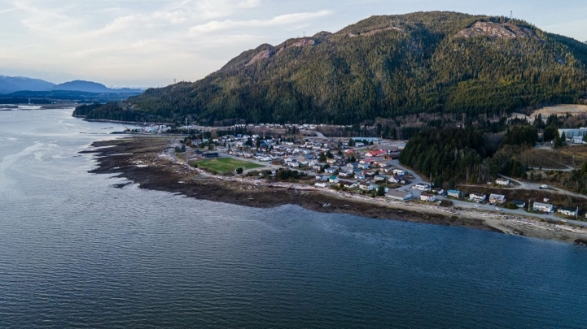
https://haisla.ca/

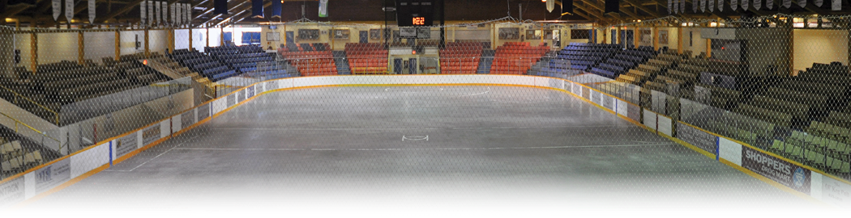
Tamitik Arena

At the heart of downtown Kitimat, you will find the Tamitik Jubilee Sports Complex, comprised of the Aquatic center and 2 Ice Arenas.
Tamitik Arena, Kitimat Ice Rink (KIR - currently under renovations)
& Sam Lindsay Memorial pool & facilities
Home to the Kitimat Winterhawks (BCMH) and

the Kitimat Ice Demons (CIHL)

Amenities:
- 5 dressing rooms
- Heated seating area
- Meeting rooms
- Press box.
- Referees room.
- Skate sharpening

- Concession
- Upper and lower public washrooms
- Walking track
- Seating capacity for 1977 (+400 standing)
- Handicap accessible with viewing area.
Players please enter the arena through the lower doors. The lower parking lot is for player drop off/pick-up only.

Accommodations
When calling the below accommodation please reference
"U13 Tier 4 BC Hockey Championships"

Kitimat

MStar Hotel
150 City Centre Mall
1-250-632-7600

Microtel 635 Dadook Ave
1-778-655-3494

The Chalet Inn
864 Tsimshian Blvd
1-250-632-4615

Kitimat Lodge
656 Dadook Ave
1-778-655-3494

Kitimat River Motels & Suits
650 Kuldo Blvd
1-778-631-2841

Minette Bay Lodge
2255 Kitimaat Village Road
1-250-632-2907

Terrace (40min drive)

Holiday Inn Express & Suits
3059 Hwy 16 East Terrace
1-778-634-3977

Sandman Hotel
4828 Hwy 16 East Terrace
1-250-635-9151

Comfort Inn & Suits
5112 Hwy 16 West Terrace
1-778-635-0788

Days Inn by Wyndham
4620 Lakelse Ave
1-250-638-8141

Restaurants (Kitimat)

Rosarios Restaurant
Mr. Mikes Steakhouse
PF Pizzeria & Bistro
Timmy’s Deli
Pizzarama Pizzaria
Pedro’s Grill
The Chalet
The Blue Room Tavern
The Kuldo Restaurant
Domino’s Pizza
Hirsch Creek Bar & Grill
McDonalds
Office Bar / Bistro
Ella’s cafe

Two Peaks Brewing
Chop Suey Kitchen
Fortune Kitchen
Tim Hortons
A & W
Subway
Dhamka Indian Restaurant
Mucho Burito
Chester Chicken
Sushi J’s
Dollys
Nanas coffee shop
Chilly & Dancer Pub
Tamitik Arena Concession
*Variety of food trucks

Come visit the raffle table to see restaurant specials for Teams

Grocery Stores (Kitimat)

Kyle’s No Frills
Save on Foods
Tony’s Corner Store

Restaurants (Terrace)
https://www.visitterrace.com/eat-and-drink/restaurants/
Terrace restaurants

Grocery (Terrace)
Terrace Grocery Stores

Travel To Kitimat
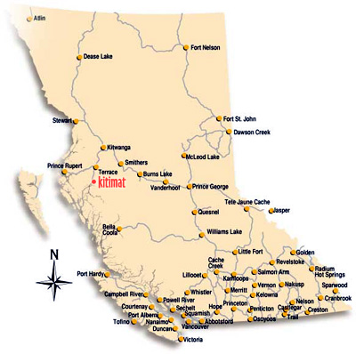

By Road

- The distance from Vancouver BC to Kitimat BC is 1421.58 km.
- The Vancouver BC to Kitimat BC driving time is 17 hours and 32 minutes.
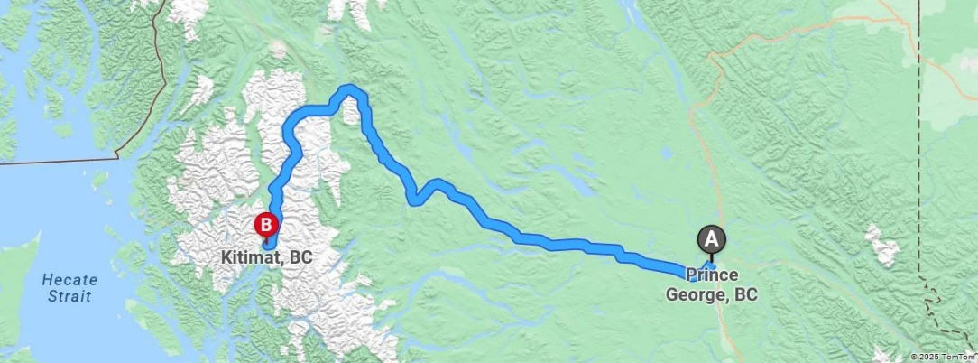
- The distance from Prince George to Kitimat is 641 kilometers by road.
- Road takes approximately 8 hours and 31 minutes and goes through Terrace, Vanderhoof, Vanderhoof, Fort Fraser, Fraser Lake, Endako and Burns Lake.
Road Conditions: https://www.drivebc.ca/

By Air

Northwest Regional Airport (YXT)
Offers daily flights to destinations including Vancouver, Kelowna, Victoria, Prince George and Prince Rupert.
40 min drive from Kitimat.
103-4401 Bristol Rd., Terrace, BC,
V8G 0E9
(250) 635-2659
Visit Website
Westjet: Westjet Website
Air Canada: Aircanada Website

Rental Vehicles
Enterprise
Budget Rentals
Fox Rental Car
Driving Force
Hertz Car Rental
National Car Rental

BC Ferry
Inland Coastal Ferry
Port Hardy / Bella Coola / Prince Rupert

Championship Event Schedule

Saturday, March 14th
- Tournament Banquet 4:00 doors open, arrive no later than 4:30pm
- Coaches Meeting Immediately after banquet

Sunday, March 15th
- Day 1 Game Play
- 5:00pm Community Pre-Party
- 6:30pm Opening Ceremonies (Teams to be in lower concourse by 6pm)

Monday, March 16th
- Day 2 Game Play

Tuesday, March 17th
- Day 3 Game Play

Wednesday, March 18th
- Day 4 Game Play
- 7:30pm - Championship Game

Game Schedule
U13 Tier 4 BC Championships Kitimat Schedule
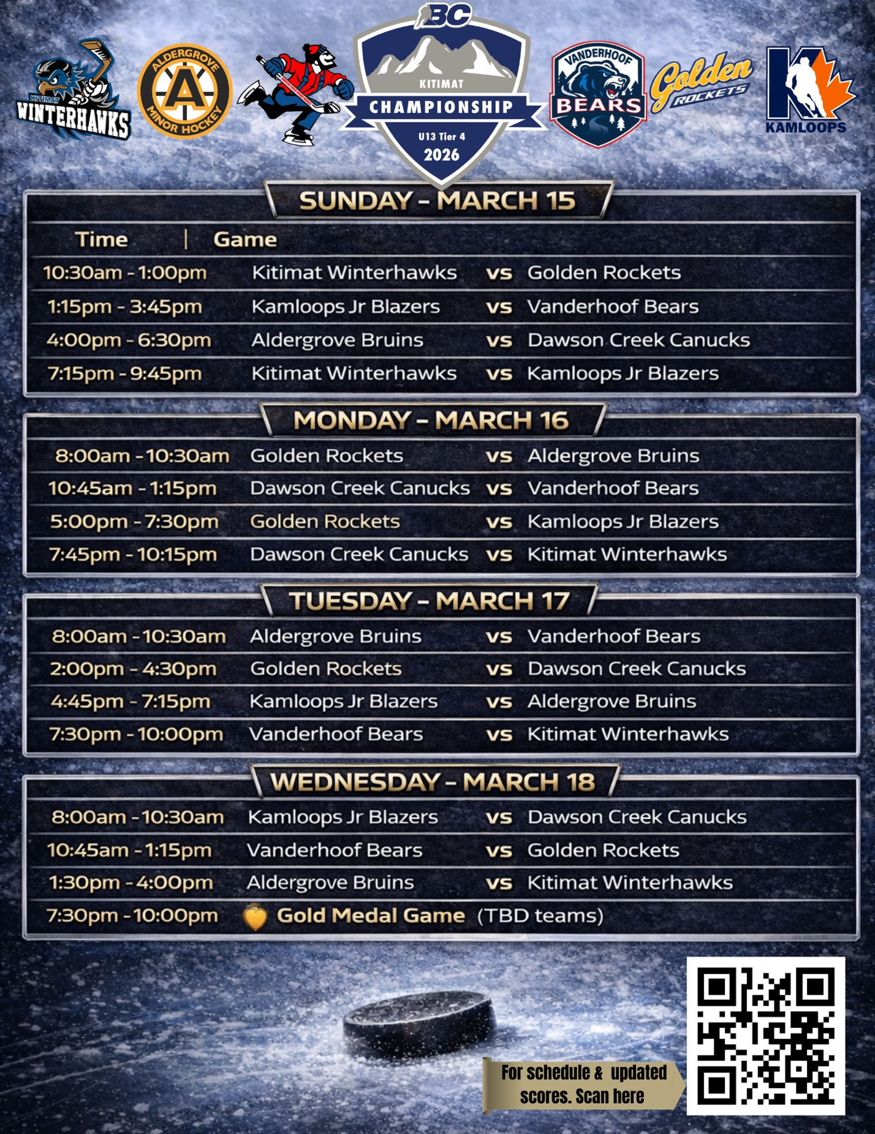
The schedule is posted online AWAY team at HOME team. Home teams where white/light and visiting teams wear dark.

Championship Banquet
Semi formal attire please
Saturday, March 14th
Mandatory all teams to participate.
Luso Canadian Club
159 Konigus St, Kitimat, BC
4:00 pm doors open
Arrival no later than 4:30pm please
Theo Fleury will the guest speaker, each team will have about 10 minutes of one-on- one time with him.
Please bring raffle basket with you to the banquet

Coaches Meeting
Saturday, March 14th
Mandatory for Coaches to attend.
Immediately following the Banquet at Luso Canadian Club

Community Pre- Party
Sunday, March 15th 5:00pm-6:30pm
Tamitik Jubilee Sports Complex / Arena
Prior to Opening Ceremonies

Opening Ceremonies
Sunday, March 15th
Tamitik Arena
6:30PM
Mandatory for all teams to participate.
Teams to be in lower Concourse for 6pm

Medal Presentation
Wednesday, March 18th
Following Championship Game
Medals handed out / Closing remarks.

Things to do.
Tamitik Jubilee Sports Center
Aquatic Centre - District of Kitimat
waterpark, water slide, lazy river, diving boards, Sauna & Hot tub.

Riverlodge Recreation Centre – Riverlodge Recreation Centre

Kitimat Museum – Kitimat Museum
Located just steps away from the Arena, free to visit. Kitimat wildlife display and history of Kitimat and the Haisla.

Kitimat Hirsh Creek Golf & Curling Club - Hirsch Creek Golf Course
Restaurant, Curling and Golf Simulator

Community trails/points of interest - Kitimat Hiking Trails

City Centre Mall - Shopping in Kitimat

Terrace, BC

A short drive from Kitimat, Terrace offers additional shopping, dining and recreational options.
Tourism Terrace | Explore Northwestern BC

- Shopping: Skeena Mall skeenamall.com
- Recreation & Entertainment:
  - Bubbleland www.bubbleland.ca
  - Terrace Aquatic Centre Terrace Aquatic centre
  - Terrace Movie Theater - tillicumtheatres.com

Skate Sharpening

Sparky’s Edge Skate Sharpening
It is conveniently located in the lower Tamitik Arena Lobby.
Contact info: 250-639-4368
sharpenerguy@gmail.com
Hours: Tournament hours will vary, text him if you need sharpening and he isn’t there

Ron’s Mobile Fishing Tackle and Bait Shop
Located Next to the KIR Arena
380 City Centre
Contact info: Ron Wakita 250-632-1275
wakita@telus.net
Sports Stores
Please ensure you have everything you need (and maybe a couple spares)
The closest Sports store is located in Terrace.

Terrace Sport Chek
Skeena mall-Unit #230, 4741 Lakelse Avenue
Terrace, British Columbia, V8G 4R9
250-635-1508
Get directions

Sport Chek, Smithers
Dan’s Source for Sport, Smithers
Evolve Sport and Cycle, Smithers

Emergency Services
For medical assistance or emergency support please see Raffle table, first aid level one at minimum will be onsite and first aid kit at table.

The Kitimat General Hospital (KGH) and Health Centre is a Level 4 trauma center, providing emergency and medical services to the community.
These services are managed through Northern Health

Dial 911 in case of Emergency

For Risk Manager Planning: Arena Address for 911 calls
Tamitik Jubilee Sports Centre (Lower Arena Entrance)
400 City Centre
1-250-632-8955

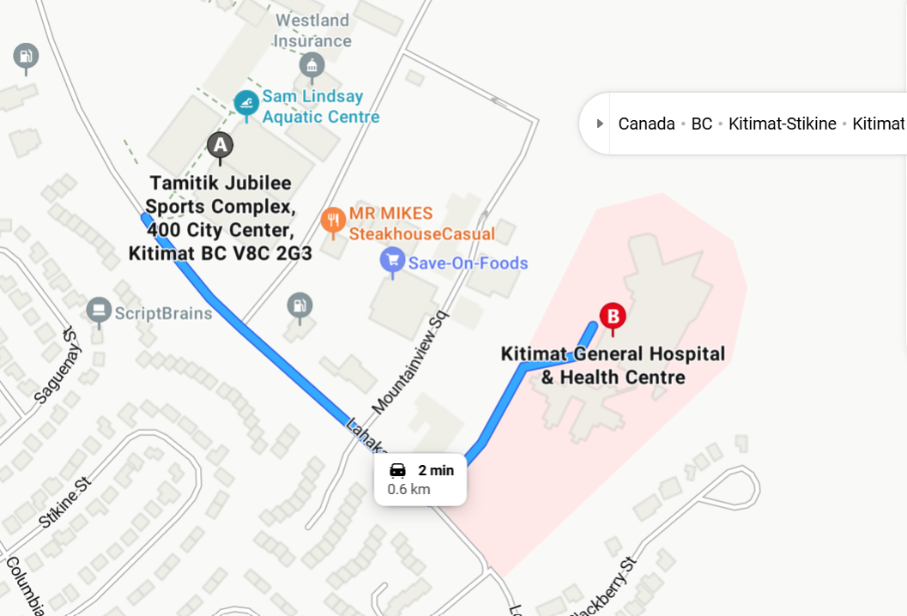

Tournament Information

CONGRATULATIONS! Your team has made it to the Provincial Championship!
We look forward to hosting you and seeing you in action.
We request the following information be sent to Kitimatu13host@outlook.com
as soon as possible to ensure your team is well represented in any print material

- Team photo-in the program and other print materials. Please include names of all players/coaches/ support staff (full name, Jersey number)
- Individual Headshots- Please send high resolution individual headshots of each player attending the BC Championships
- Association Logo – please send highest resolution image of your association logo and home jersey colors
- Official Roster- please email official rosters
- Nicknames-please send roster with numbers and nicknames
- Contact information – please provide Head Coach and Team Managers names and contact numbers.
- Equipment Checklist (see further down for more details)
- A Team video showcasing your team/players and where they came from. Video to be shared at Banquet and on Tournament social media. Video should reflect appropriate gender, cultural content with the spirit of teamwork, comradery and values of BC Hockey.
- Optional but extremely appreciated – A Basket to add to our raffle basket table with items that represent the town that you came from.

Relief Goalie
U13 Kitimat Goalie
Ryden Calado

Tournament Facebook Page

Kitimat U13 Tier 4 BC Championships
U13 Tier 4 BC Championship Facebook Page

Game Livestream

Tamitik arena uses “Live Barn” that will be available to subscribe to for live streaming of all the games.

Teams are also welcome to independently stream their own games on their pages/platforms.



Photographer

An amazing local photographer, Paula Keech, has been contracted by the tournament hosts to photograph all games, each day and events for the U13 Championships. Photos will be uploaded throughout the tournament to enjoy viewing or online.

Each team has the opportunity to purchase their team’s entire tournament photos as a package deal for $600.
Once purchased the team has access to photos online when they uploaded.

We encourage all teams to support this amazing local photographer
The payment can be made to kitimatu13host@outlook.com via e-transfer or cheque when you arrive.
There will not be an option to purchase individual photos from the photographer (as they will be busy taking photos and getting them uploaded)

U13 Tier 4 Merchandise Store
U13 tier 4 Championship Merchandise order link

Ensure that team members order by March 5th 11:59PM to have order shipped to the tournament.

All Items ordered March 6th, 12AM will be shipped to the individual’s home after the Championships and subject to a $15 shipping fee.

Fair Play Award
The Fair Play Award will be determined by a ballot vote conducted by participating teams, referees, and selected representatives. The selection process reflects our BC Championship theme:
Stronger Together: Teamwork, Resilience, and Community
recognizing the team that best demonstrates respect, sportsmanship, perseverance, and a commitment to uplifting others both on and off the ice|
A local carver, Brad Starr, has designed a beautiful piece for the winning team.

Equipment Checklist

As per BC Hockey, prior to each team’s first game (and possibly during the tournament) an equipment check will be conducted by a Referee Committee member with a referee or the BC Hockey Representative
Please see appendix 1 for reference

Raffle Basket table

There will be a Raffle basket table with some amazing baskets as well as optional baskets brought from the participating teams to reflect their community.

Programs

U13 Tier 4 Championship Programs will be available for purchase
They will include all teams participating in the Championship tournament.
Cost to be determined

On site Merchandise

There will be a limited amount Championship merchandise available to purchase.
we encourage your teams to check with the table as the stock will be limited.
Items planning to have available include: Cowbells, cups, etc

Online 50/50 via Rafflebox

There will be an online 50/50 during the tournament
Rafflebox Link

