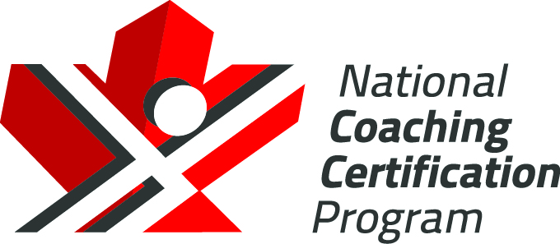

Hockey Canada

High Performance 1  
Mental Preparation:  
Reference Material

Version 1.4, 2021



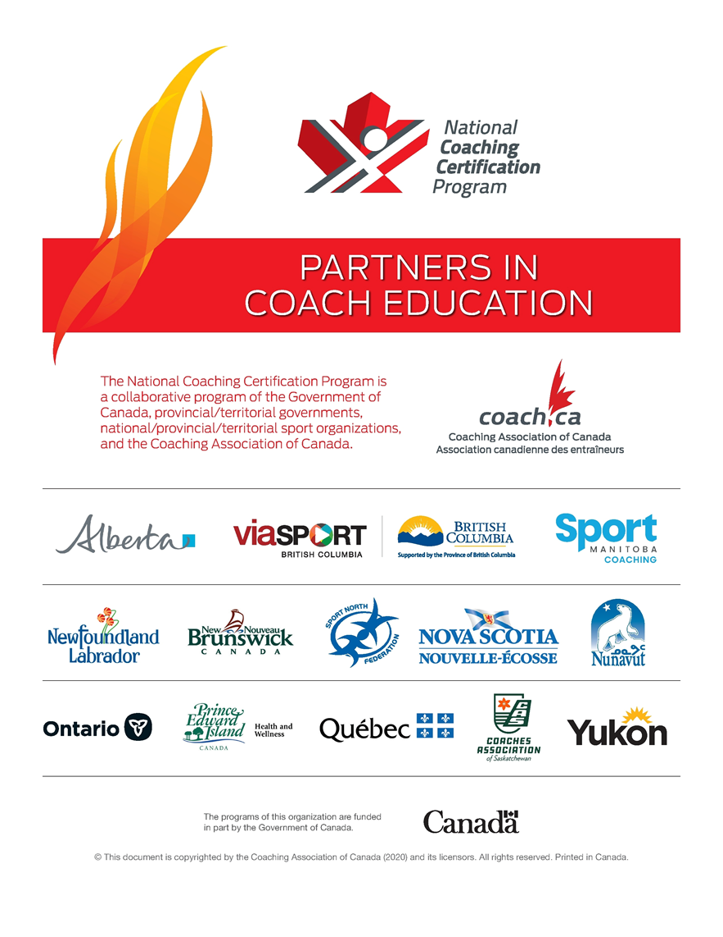

Table of Contents

Setting Effective Goals 1

Types of Goals 1

Outcome Goals 1

Performance Goals 2

Process Goals 2

Developing/Revising a Focus Plan 3

Work with Your Athletes 3

Tell Athletes about Focus 3

Ask Athletes Good Questions 4

Visualization 6

General Tips 6

Practice-specific Tips 7

Sample Visualization Activity 7

Visualization Exercise 7

References 9

Websites 9

**The Collection, Use, and Disclosure of Personal Information**

The Coaching Association of Canada collects your NCCP qualifications and personal information and shares it with all NCCP partners according to the privacy policy detailed at [www.coach.ca](http://www.coach.ca). By participating in the NCCP you are providing consent for your information to be gathered and shared as detailed in the privacy policy. If you have any questions or would like to abstain from participating in the NCCP please contact [coach@coach.ca](mailto:coach@coach.ca).

***The programs of this organization are funded in part by Sport Canada and the Public Health Agency of Canada. The views expressed herein do not necessarily represent the views of the Public Health Agency of Canada.***

# Setting Effective Goals

When we set goals, we often set long-term, far-off goals and don’t really focus on the present — what we can and probably should be doing today to achieve that long-term goal. Here are some tips for how you as a coach can bridge that gap:

* Set goals *with your athletes*. This encourages them to set more effective goals.
* Talk with your athletes about what they want to achieve.
* Tell your athletes you will support them as they pursue these goals.
* Educate your athletes about the training they must do to achieve their goals.
* Point out to your athletes how goal-setting is related to focus: that athletes will be focusing on small, daily goals.
* Regularly assess whether your athletes are achieving their goals, and adjust goals as needed for ongoing and long-term success.
* Assess goals *with* your athletes. It helps them understand that goals are about choices, and it empowers them by getting them to take more responsibility for themselves.
* Don’t be afraid to help athletes set challenging goals — it can inspire them to believe more in themselves.

Goals are important for athletes returning to play from an injury or concussion.

## Types of Goals

Setting effective goals involves setting three very different types of goals:

* Outcome goals
* Performance goals

Process goals

### Outcome Goals

* Outcome goals focus on results, such as winning a competition or medal, or scoring more points than an opponent.
* Outcome goals are necessary, but they can cause athletes stress on competition day.
* Outcome goals can act as motivators when competitions are far in the future.

Whether athletes achieve these goals depends on their own personal effort, as well their opponent’s performance.

### Performance Goals

* Performance goals focus on achieving one’s own performance objectives, e.g., running a specific time in a race.
* These goals are more flexible and give athletes a greater sense of personal control.

Focusing on performance goals can be very helpful for athletes returning to play after an injury or concussion.

### Process Goals

* Process goals focus on the actions/movements that need to be carried out in a good performance.
* These are the best kinds of goals to be thinking about on competition day, because they relate most closely to an athlete’s best focus.

These goals can help athletes returning to play after an injury or concussion.

# Developing/Revising a Focus Plan

To develop or revise a focus plan, you need to:

* Work with your athletes
* Tell athletes about focus

Ask athletes good questions

**Remember, a good, well-trained focus plan creates a confident athlete,** because he or she knows and has trained what to be thinking and feeling.

## Work with Your Athletes

You probably know more about focus and psychological skills than most of your athletes, but you *don’t* know more than they do about what works and doesn’t work for them psychologically. That’s why you need to create focus plans *with* your athletes.

Simply put, developing focus plans with your athletes:

* Makes for more accurate focus plans, because you have athletes’ own input
* Saves everyone time and energy, because the focus plans are more accurate

Increases athlete commitment, because athletes helped develop them

The athlete’s personality plays a key role in his or her ability to focus and in the kind of focus plan that will work for him or her. For example, athletes who tend to become overanxious need fewer thoughts in their focus plan. For each athlete you coach, you need to know the answers to questions like these:

* Is the athlete fairly calm and focused in training and competition?
* Is the athlete more anxious about various aspects of competing?

Is the athlete overcoming an injury or concussion?

Before you jump right in and start working on focus plans with your athletes, you need to tell them about focus.

## Tell Athletes about Focus

Communicating openly and telling athletes *about* workouts — the why and how of them, for example — is a key part of coaching well. It increases the trust between coach and athlete, and most athletes are more committed when they know *why* they’re doing things.

So take a few minutes before starting to work on a focus plan, and tell athletes about focus: what it is, what a focus plan is, why focus matters, and how athletes will work on focus:

* Focus is what you’re thinking about and feeling *now*, in the moment.
* A focus plan is a detailed list of all the things athletes need to think about and feel to perform well.
* Focus matters because it’s an essential aspect of performing well in sport. And while focus is a very simple skill, it’s also very hard to do. Why? Because so many things, such as distractions and the emphasis on winning, get in the way.
* To focus well in competition, athletes must have the right focus, or they’ll make mistakes.
* Athletes can’t wait for competitions to work on focus. To focus well in competition, they need to train their focus *every day*.
* Sometimes athletes aren’t particularly focused for training sessions. It’s an important part of your role as a coach to design and direct practices that get them focused.
* It often helps to get athletes to think about what they’re doing and trying to accomplish, for example, in a particular training session. One simple but effective way to do this is to ask them what they’ll work on in training rather than always telling them “Here’s what we’ll do.” This ensures the athlete is actually engaged, thinking, focused.
* To train their focus, athletes need to follow a plan that will prepare them to think about and feel the things they need to think about and feel to perform well.

Being focused is hard work. You’re asking athletes to be fully focused in physical training every day, as well as whenever you’re discussing training, talking strategy, watching video, training in the gym, visualizing, etc. Outside those times, there are many hours in the day when the athlete should NOT be totally focused on his or her sport but should be resting, eating well, studying, taking classes, etc.

## Ask Athletes Good Questions

To perform at their best, athletes need to be aware of the focus that works for them. It’s one of your main jobs as a coach to help them discover this focus.

This involves asking athletes good questions, listening to their answers, asking them even more good questions, and incorporating the answers you develop together into the focus plan.

Start this process by:

* Asking athletes to reflect on one of their best races/games/performances. What were they thinking and feeling?
* Asking athletes to do the same for a not-so-great race/game/performance. This will begin to tell you about what focus is best for the individual athlete.
* Ask them about their preferred focus and strengths. Emphasize the need to:
* Focus on internal and external cues such as thoughts and feelings that help athletes perform optimally

Act in ways that help good performances happen

Then work with your athletes to translate this information into a focus plan. Here are some questions you can ask to call on your athletes’ self-awareness and get at THEIR best focus.

* What do you need to be thinking about to perform well?
* What do you need to be feeling to perform well?
* What strategies do you need to execute to perform well?
* What do you need to do to handle an opponent who performs unusually well?
* What do you need to do to handle an opponent who performs unusually badly?
* What distractions do you have to be able to handle to perform well?

What skills do you need to be able to apply to perform well?

Asking effective questions is the key to finding out what’s happening with your athletes. You need to ask good questions, questions that get at what’s really going on, and you have to listen to and probe your athletes’ answers. This is an ongoing process of learning and self-discovery for you *and* your athletes, as you learn together what works and what doesn’t work.

# Visualization

We have images, thoughts, and feelings in our mind all the time. To perform well, athletes need to be in control of these images, and they need to “see” and “feel” themselves performing well.

What is visualization?

* Visualization is a skill that allows athletes to create a blueprint of how they want to be, what they want to be focused on.
* Visualization is an opportunity to create a positive reality; it also allows athletes to be well prepared for competition.
* Visualization is closely linked to focus, because we often want athletes to be visualizing their focus plan — what they want to be thinking and feeling while competing.

Visualization is a skill that can give athletes the confidence to return to play after an injury or concussion.

How can athletes learn to visualize effectively, and what can you do to help them?

## General Tips

* Visualization is like any other skill — athletes need to practise it regularly to get better at it.
* Visualization must be positive. This is the ONLY RULE about visualization. There is no point visualizing a poor performance, a mistake, bad technique, an injury, etc.
* Work with your athletes to find out what works best for them. Some athletes can see themselves executing a skill or remembering a past good performance; for others, it’s more of a feel.
* Athletes do NOT always need to be lying down when they visualize. It is often useful for athletes to approximate the position they will compete in. For instance, in canoe/kayak or rowing, athletes could sit and create small movements as they visualize their race.
* Athletes can visualize skills from an internal perspective (doing it) or from an external perspective (as if watching the skills on video). Both perspectives are OK.
* Athletes can visualize just about anything: specific technical aspects of a skill, tactical plans, race focus plans, past best performances, future competitions, feelings of confidence, etc.

It can be hard to know how well an athlete is visualizing — it often helps to sit with an athlete while he or she visualizes and then ask for feedback.

## Practice-specific Tips

* Integrate visualization into daily training — whenever you make a technical suggestion or correction, ask the athlete to visualize the change/correction in his or her mind before trying it physically.
* Start with visualizing a skill the athlete is already good at or a past good performance. This ensures that the athlete will be able to see and feel the skill or performance.
* Start out by having your athletes practise visualizing for 3-5 minutes three times a week.
* Once you’re sure your athletes can visualize effectively, encourage them to start visualizing races or game performances.

If an athlete gets stuck on a negative image, for example, falling in practice, go back to visualizing a simpler skill, where the athlete can see himself or herself successfully performing the skill.

## Sample Visualization Activity

The following is an example of an activity to introduce athletes to visualization. It starts with visualizing a daily activity that athletes can relate to and then progresses to a sport-specific application.

* Ask athletes to visualize something they know well.

Ask them questions about their visualization to confirm that all athletes visualize on the same item or in the same way.

### Visualization Exercise

* Visualize a daily activity:
* Sit in a relaxed position and close your eyes.
* Imagine you are walking into your home, through the door and into your kitchen. Hear any sound you might hear in this kitchen, see the colours, smell the smells. Is your mom there? Walk over to the fridge and open it.
* Feel the cool air that hits you when you open the door and the light comes on. Find out where the lemons are, and pull out a big yellow lemon. Feel the weight of the lemon in your hand, and feel its texture.
* Close the door, and find a cuttingboard and knife. Cut the lemon in half. See the beads of juice on the knife, and smell the scent of the lemon. Now cut the lemon into quarters. Pick up one of the four quarters, smell it, and bite into it.
* Reflecting on your visualization, answer each of the following questions with a rating from 1 to 10, with 1 meaning *Not at all* and 10 meaning *Very clearly*:
* Could you smell the lemon?
* Could you feel the lemon, door handle, and house?
* Could you taste the lemon?
* Could you hear sounds?
* Did you see in colour or in black and white?
* Could you feel your body moving?
* Discuss your visualization with other athletes.
* Visualize a sport-specific skill. Choose a simple skill in your sport, for example, a shot in basketball. This visualization helps you *feel* movements and enhances the physical skill involved. For basketball:
* Start by shooting 1 metre from the hoop and making the shot. Then close your eyes and do the same thing. Make the shot with your eyes closed.
* Then look at the rim, close your eyes, and *see* the rim. Now see and feel the ball going into the hoop. Then shoot the ball.
* Do this step by step, and gradually increase the distance from the basket.

# References

K. Grand’Maison and T. Orlick. 2006. “Focusing Lessons from an Elite Ironman Triathlete: Chris McCormack.” *Journal of Excellence*, 11. 2006.

T. Orlick. *In Pursuit of Excellence:* *How to Win in Sport and Life through Mental Training*. 4th edition. Champaign, IL: Leisure Press. 2008.

Parachute. *Concussion Questions and Answers*.Available at parachutecanada.org ([www.parachutecanada.org/active-and-safe/item/concussion-questions-and-answers](http://www.parachutecanada.org/active-and-safe/item/concussion-questions-and-answers)).

J. Syer and C. Connelly. *Sporting body, sporting mind: An athlete’s guide to mental training*. London, UK: Simon & Schuster. 1998.

T. Tutko. *Sport Psyching: Playing your best game all of the time*. New York: J.P. Tarcher. 1976.

R. Weinberg and D. Gould. *Foundations of Sport and Exercise Psychology*. 4th edition, Champaign, IL: Human Kinetics. 2007.

P. Werthner. “The Nature of Effective Concentration before and during a High Performance Event.” *Journal of Excellence*, 6, 15-35. 2002.

P. Werthner. “Interview with Steve Giles, 2000 Olympic Medalist.” *Journal of Excellence*, 6, 86-103. 2002.

J. M. Williams (Ed.). *Applied Sport Psychology: Personal Growth to Peak Performance*. 5th edition. New York: McGraw-Hill. 2005.

## Websites

<http://www.humankinetics.com/products/showsubject.cfm?cat1=coaching&cat2=sprt_psyc&cat3=all_sport_psy>. Accessed October 14, 2008.

<http://www.pponline.co.uk/encyc/psychology.htm>. Accessed October 14, 2008.

